Macromolecular dynamics. Conformational Mechanics

1. Dynamics of polymeric chains

a. Molecules move in the direction of decreasing potential energy

Molecules are subject to continual motions at equilibrium conditions due to intramolecular and intermolecular interactions, even in the absence of any external field. In the classical treatment of molecular mechanics, conformational motions are described by Newton’s law

Fi = m_{i} a_{i} = - ∇iV (VI.1.1)

where Fi is the force experienced by the particle (or atom) i due to the presence of the potential energy V, m_{i} and a_{i} are the respective mass and acceleration of particle i. ∇i designates the gradient operator with respect to the position Ri of particle i. The x-, y- and z-components of Fi are found from the partial derivatives of V with respect to the three components X_{i}, Y_{i} and Z_{i} of Ri as

F_{ix} = - ∂V/X_{i}
F_{iy} = - ∂V/Y_{i} (VI.1.2)
F_{iz} = - ∂V/Z_{i}

The negative sign indicates that the spontaneous force exerted on the particle i is in the direction of decreasing energy. Molecular dynamics simulations are deterministic approaches based on the application of eq VI.1.1 to all particles, after suitable definition and semi-empirical parameterization of the potential V. The latter is still a challenge and one of the major drawbacks for realistic simulation of molecular dynamics in different media.

b. Polymer dynamics involves two types of motion: flutuations near isomeric states and transitions between isomers

The rotational isomeric states (RIS) description of polymer conformations has found wide utility for understanding the statistical mechanics of macromolecules [Flory, 1969 #61]. In this description, In this description, bond rotations are approximated by discrete rotational isomeric states that correspond to minima in bond rotation (or torsion) energies. Bonds preferentially assume rotational angles in the close neighborhood of these minima.

The fraction of bonds in a given rotational isomeric energy well is assumed to be equal to the fractional time a given bond occupies that particular well. This is a basic feature of ergodic processes: ensemble and time averages are equal.

In conformity with the equilibrium distribution of isomeric states, macromolecular dynamics involves two basic mechanisms of motion [Bahar, 1994 #106]:

(i) fluctuations near rotational isomeric states
(ii) conformational transitions or jumps between isomeric states.

Fluctuations. Molecules enjoy fluctuations in bond lengths, bond angles, and bond torsional angles. Fluctuations are generally controlled by harmonic potentials. See for example the equations in § IV.6 for bond stretching and bond angle distortions. A generic form for harmonic potentials that describe the departure ΔR_{i} = R_{i} - R_{i}⁰ from the equilibrium coordinates R_{i}⁰ reads

V(ΔR_{i}) = (1/2) k_{Ri} (ΔR_{i})² = (1/2) k_{Ri} (R_{i}- R_{i}⁰)² (VI.1.3)

The forces associated with a harmonic potential are linear, i.e. they vary linearly with the deformation ΔR_{i}. They are given by the Hooke’s law

Fi = - k_{Ri} ΔR_{i} (VI.1.4)

Exercise: Show that F_{ix} = - k_{Ri} (X_{i}- X_{i}⁰) or F_{i} = - k_{Ri} (ΔR_{i}) for a harmonic potential. Hint: replace (ΔR_{i}) in eq VI.2.3 by [(X_{i}- X_{i}⁰)² + (Y_{i}- Y_{i}⁰)² + (Z_{i}- Z_{i}⁰)² ]^{1/2} and apply eq VI.2.1.

The negative sign indicates that the force experienced by the particle is in the direction opposite to that of the deformation ΔR_{i}. The force constants are relatively stiff (large) in the case of bond length stretching, and soft for torsional fluctuations. In accordance, the fluctuations in bond lengths are fast, of the order of tenths of picoseconds for polymeric chains in solution; whereas torsional librations are at least two orders of magnitude slower.

Conformational transitions. This type of motion involves a passage over an energy barrier. The passage between rotational isomeric states embodies one or more stepwise changes in bond rotational angles, as shown in Figure VI.1.1. The accompanying forces are evidently non-linear, as can be deduced from the gradient of anharmonic potentials such as Lennard-Jones potentials, or intrinsic rotational potentials operating for these conformational processes. The frequency of isomeric jumps per bond is of the order of tenths of nanoseconds, such that typical MD trajectories of the order of nanoseconds for polyethylene chains of 100 or more rotatable bonds, for example, exhibit hundreds to thousands of rotational jumps.

Figure VI.1.1. Time evolution of a bond dihedral angle, typically observed in Brownian or molecular dynamics simulations of polyethylenelike chain dynamics. Three rotational isomeric states are preferred, characterized by dihedral angles of 0, 120° and -120°. The bond undergoes torsional fluctuations at those isomeric states and occasional jumps between them.

c. Fluctuations and conformational jumps are generally coupled to localize the motion

Due to non-local effects imparted by chain connectivity and non-bonded interactions, the rotational jumps occur either in couples, or in concert with fluctuations that accommodate the conformational changes [Haliloglu, 1996 #167]. These two types of rotational motions are called correlated and isolated transitions, respectively.

Correlated rotations. Figure VI.1.1 illustrates the most commonly observed types of correlated jumps for linear polyethylenelike chains [Helfand, 1971 #263; Helfand, 1984 #264]. These involve the simultaneous rotational jumps of two bonds. They are called gauche migration and gauche pair production/annihilation, respectively, consistent with the type of isomeric transition taking place in each case. The coupled rotations of the bonds leaves the orientations of the tails unchanged, such that the conformational change can be confined to a short segment, i.e. localized along the chain. There are other types of transitions that localize the motion more efficiently leaving both the orientation and location of the tails unchanged, such as the crankshaft motion illustrated in Figure VI.1.2. However, these involve the simultaneous rotation of more than two bonds, each involving a passage over an energy barrier; and are not as frequent as expected. Yet, in dense media where intermolecular resistance to motion can be stronger than intramolecular conformational barriers, the drive for efficient localization of motion can favor this type of coupled transitions.

Figure VI.1.2. Two types of conformational transitions commonly occurring in polyethylene-like chains: (a) gauche migration, given by the scheme g±tt < == > ttg±, and (b) gauche pair production/annihilation, of the form g+tg- <==> ttt. Two coupled rotations occur in each case to preserve the spatial orientations of the tails, while moving their absolute positions. (Figure 2 of [Helfand, 1984 #264])

Isolated rotations, on the other hand, are single bond rotations accompanied by cooperative fluctuations distributed over longer length scales along the chain. Like correlated transitions, the effective isolated jumps can leave almost unperturbed the orientation of the tails surrounding the mobile segment. The conformational changes are localized in this case by the fluctuations of the neighbors along the chain. The localization length depends on the stiffness of the potentials controlling the backbone geometry, and thereby on the chemical and geometric properties of the chain, as well as on the strength of intermolecular constraints that increase with density [Bahar, 1992 #23; Bahar, 1992 #24; Bahar, 1994 #21; Bahar, 1997 #109].

In general, correlated rotations - in which at least two rotational energy barriers are to be surmounted simultaneously - are less frequent than single bond rotations accompanied by accommodating fluctuations. Cooperative fluctuations play thus an important role in driving and/or stabilizing conformational transitions [Moro, 1990 #155; Baysal, 1995 #45; Baysal, 1996 #46].

Figure VI.1.3. Crankshaft motion of a polymer segment. Note that the spatial positions of the terminal atoms and the orientations of the terminal bonds are preserved during the transition. The conformational motion is thus localized to the displayed segment of nine bonds. Figure 1 of [Helfand, 1971 #263])

4. Molecular Dynamics Simulations

a. Basic Principle: Solution of Newton’s Equation of Motion

Molecular dynamics (MD) simulations are based on the solution of Newton’s equation of motion, as applied to each atom in the simulated system. Suppose the system consists of N interacting particles (usually atoms). A MD trajectory is generated as a succession of a large number (~10⁶) of steps, each of which involves the simultaneous solution of a set of 3N differential equations of the form

m_{i} ∂²R_{i}/∂t² = F_{i} = - ∇_{ri} V (VI.4.1)

for 1 ≤ i ≤ N. Equation VI.4.1 is nothing else than a simple mass balance, or the classical Newton’s equation of motion, for particle I, subject to potential energy V. V includes both intramolecular (bonded and non-bonded) and intermolecular interaction energies (see Box VI.4.1), and ∂²R_{i}/∂t² is the second derivative of R_{i} with respect to time, or the acceleration a_{i} of particle i, by the action of the gradient of the potential. The negative sign indicates that the particle accelerates in the direction of decreasing potential. For each atom i, equation VI.4.1 represents a set of three equations, as

m_{i} ∂²X_{i}/∂t² = - ∂V/∂X_{i}
m_{i} ∂²Y_{i}/∂t² = - ∂V/∂Y_{i} (VI.4.2)
m_{i} ∂²Z_{i}/∂t² = - ∂V/∂Z_{i}

Each MD step involves two types of calculations: (i) evaluation of the total potential given the instantaneous coordinates r_{i} of all particles, (ii) differentiation of the potential with respect to the position vectors, for evaluating the acceleration of each particle. The total force on particle i thus results from the addition of several contributions to V, which are r_{i}-dependent. The accelerations are conveniently inserted in a numerical algorithm, based on finite difference techniques, for calculating the new set of position vectors, as described below.

- Force Field in MD simulations: an important determinant of the realism of trajectories

The instantaneous acceleration, and thereby displacement of each particle depends on the potential it experiences. MD trajectories are thus sensitive to the potential or the so-called force field selected for performing the simulations. The accuracy of the MD results are limited by the accuracy of the force field.

Several force fields have been developed for MD simulations, the most widely used ones being CHARMM, AMBER, etc. The force fields are empirical – or semi-empirical, i.e. the complete set of energy parameters are usually adjusted to accurately reproduce known experimental data. An important component of the force field is the model used for representing the solvent (usually water). Two fundamentally different approaches have been adopted in previous simulations: explicit or implicit models for the solvent. In the former, all solvent molecules/atoms are explicitly considered, whereas in the latter the solvent effect is described by an effective dielectric constant. Explicit consideration of solvent increases the number of interacting particles by about one order of magnitude, which is directly reflected upon the effective computational time. Implicit solvent models are more efficient but may lack realism. Efficient and accurate modeling of solvation, and in particular hydration effect, is still a challenge.

It is customary to describe the potential in terms of two major groups of interactions, bonded and non-bonded (Box VI.4.1). In the simplest model, non-bonded potential include the electrostatic (charge-charge, charge-dipole, dipole-dipole) and van der Waals interactions. Bonded interactions result from the deformations in bond lengths, bond angles and bond torsional angles. MD force fields usually contain more detailed potentials so as to fine tune the force field, such as distinguishing the van der Waals interactions between sequentially near neighboring atoms (separated by three bonds) from those occurring between farther neighbors, or including an out-of-plane energy contribution to the set of bonded interactions.

Box VI.4.1. Contributions to total potential V

Non-Bonded Interaction Potentials

Electrostatic interactions of the form E_{ik}(es) = q_{i}q_{k}/r_{ik}
Van de Waals interactions E_{ik}(vdW) = - a_{ik}/r_{ik}⁶ + b_{ik}/r_{ik}¹²

Bonded Interaction Potentials

Bond stretching E_{l}(l_{i}) = (k_{l}/2) (l_{i} – l_{i}⁰)²
Bond angle distortion E_{θ}(θ_{i}) = (k_{θ}/2) (θ_{i} – θ_{i}⁰)²
Bond torsional rotation E_{φ}(φ_{i}) = (k_{φ}/2) f(cosφ_{i})

Definitions: q_{i} = partial charge of particle I; r_{ik} = distance between particles i and k; a_{ik}, b_{ik} = Van de Waals parameters for attractions and repulsions, respectively; k_{l}, k_{θ}, k_{φ} = force constants for bond stretching, bond angle distortion and bond torsional rotation potentials E_{l}, E_{θ}, and E_{φ}; l_{i}⁰ = equilibrium length of the ith bond; and θ_{i}⁰ = equilibrium value of the ith bond angle, f(cosφ_{i}) is a function expressing the torsional potential of bond i. A common form is f(cosφ_{i}) = Σ_{n} [1+cos(nφ - η)].

Box VI.4.2 illustrates the evaluation of the gradient of the potential with respect to the position of atom i, for a non-bonded (van der Waals (vdW)) and bonded (bond stretching) potential, arising from the interaction with atom k, and from the deformation of bond i+1, respectively.

Box VI.4.2.
Example 1: gradient of vdW interaction with k, with respect to R_{i}

- E_{ik}(vdW) = - a_{ik}/R_{ik}⁶ + b_{ik}/R_{ik}¹²
- R_{ik} = R_{k} – R_{i}
X_{ik} = X_{k} – X_{i}
Y_{ik} = Y_{k} – Y_{i}
Z_{ik} = Z_{k} – Z_{i}
R_{ik} = [ (X_{k} – X_{i})² + (Y_{k} – Y_{i})² + (Z_{k} – Z_{i})² ]^{1/2}

- ∂V/∂X_{i} = ∂ [- a_{ik}/R_{ik}⁶ + b_{ik}/R_{ik}¹²] / ∂X_{i} =
where R_{ik}⁶ =| R_{ik}|⁶ = [ (X_{k} – X_{i})² + (Y_{k} – Y_{i})² + (Z_{k} – Z_{i})² ]³

Example 2: gradient of bond stretching potential with respect to R_{i}

- E_{l}(l_{i+1}) = (k_{bs}/2) (l_{i+1} – l_{i+1}⁰)² for bond i+1 (connecting atoms i and i+1)
- l_{i+1} = R_{i+1} – R_{i} = [l_{x,i+1} l_{y,i+1} l_{z,i+1}]^{T}
l_{x,i+1} = X_{i+1} – X_{i}
l_{y,i+1} = Y_{i+1} – Y_{i}
l_{z,i+1} = Z_{i+1} – Z_{i}
l_{i+1} = [ (X_{i+1} – X_{i})² + (Y_{i+1} – Y_{i})² + (Z_{i+1} – Z_{i})² ]^{1/2}

∂ E_{l}(l _{i+1}) /∂X_{i} = - m_{i}a_{ix}(l_{i+1}) (resistance to deformation exerted on i by bond l_{i+1})

= (k_{bs}/2) ∂ {[ (X_{i+1}– X_{i})² + (Y_{i+1}– Y_{i})² + (Z_{i+1}– Z_{i})² ]^{1/2} – l_{i+1}⁰}²/∂X_{i}
= k_{bs} (Δl_{i+1}⁰) ∂ {[ (X_{i+1}– X_{i})² + (Y_{i+1}– Y_{i})² + (Z_{i+1}– Z_{i})² ]^{1/2} – l_{i+1}⁰}/∂X_{i}
= k_{bs} (Δl_{i+1}⁰) (1/2) (l_{i+1} ⁻¹) ∂ (X_{i+1}– X_{i})²/∂X_{i} = - k_{bs} (1 – l_{i+1}⁰/ l_{i +1}) (X_{i+1}– X_{i})

Note that the van der Waals potential can alternatively be expressed as E_{ik}(vdW) = 4ε [ − (σ_{ik}/r_{ik})⁶ + (σ_{ik}/r_{ik})¹²], where ε_{ik} and σ_{ik} are the energy and length parameters for the specific pair ik. Show that the force of interaction between particle i and k due to their van der Waals interactions is F_{ik}(vdW) = r_{ik} /| r_{ik} | (24ε/σ) [ − (σ_{ik}/r_{ik})⁷ + 2(σ_{ik}/r_{ik})¹³].

c. Implementation of Finite Difference Methods for numerical integration of the equation of motion

Finite difference methods provide a simple means of solving the above set of 3N coupled equations of motion. The approach is to successively integrate the equations of motions using small incremental time steps δt. The most commonly used finite difference methods used in MD simulations are the Verlet (Verlet, 1967) (Box VI.4.3) and leapfrog (Hockney, 1970) (Box VI.4.4) algorithms. These originate from the Taylor series expansion of the instantaneous position vectors, truncated after the second order terms (in δt). See Box VI.4.2.

Box VI.4.3. Verlet algorithm

The method is based on positions R(t), accelerations a(t), and the positions R(t -δt) from the previous step. The equation for advancing the positions reads
R(t+δt) = 2R(t) - R(t-δt)+ δt2a(t)
The velocities do not appear in this equation. They have been eliminated by addition of the equations obtained by Taylor expansion about r(t):
R(t+δt) = R(t) + δt v(t) + (1/2) δt2 a(t) + ...
R(t-δt) = R(t) - δt v(t) + (1/2) δt2 a(t) - …
The velocities are not needed to compute the trajectories, but they are useful
for estimating the kinetic energy (and hence the total energy). They may be
calculated from
v(t)= [R(t+δt) - R(t-δt)]/2δt

Box VI.4.4. Leap-frog algorithm

v(t+δt/2) = v(t- δt/2) + δt a(t)
R(t+δt) = R(t) + δt v(t+ δt/2)

The implementation of Verlet algorithm requires knowledge of two successive sets of position vectors R(t) and R(t-δt), along with the acceleration at the second step, a(t). The former set of position vectors is the starting conformation, the second is usually found by varying all position vectors by an incremental amount, using R(t) = R(t-δt) + δt v(t), where the velocities v(t) are assigned on the basis of the Maxwell-Boltzmann probabilities

P(v_{xi}) = (mi/2πkT)^{1/2} exp (-miv_{xi}²/ 2kT) (VI.4.3)

for each component v_{xi}, v_{yi} and v_{zi} of the velocity vector v_{i} for particle i at the given simulation temperature T, and finally the accelerations are found from the negative gradient of the instantaneous potential at step t. The succeeding steps use the velocities calculated at each step, as given in Box VI.4.3. Box VI.4.5 summarizes how MD trajectories are generated using Verlet algorithm, and Figure VI.4.1. illustrates the implementation of periodic boundary conditions in MD simulations.

In the leap-frog algorithm, on the other hand, the velocity v(t+δt/2) is needed in addition to the two position vectors R(t+δt) and R(t). v(t+δt/2) is found at each step from v(t+δt/2) = v(t-δt/2) + δt a(t), except for the first step where again the Maxwell-Boltzmann distribution for velocities at a given temperature is used.

Box VI.4.5. How to generate MD trajectories?

- Selection of the simulation box containing the protein(s) and solvent molecules, usually subject to periodic boundary conditions (Figure VI.4.1)
- Known initial conformation, i.e. R_{i}(0) for all atom i
- Assign v_{i} (0), based on Boltzmann distribution at given T
- Calculate R_{i}(δt) = R_{i}(0) + δt v_{i} (0)
- Using new R_{i}(δt) evaluate the total potential V_{i} on atom I
- Calculate negative gradient of V_{i} to find a_{i}(δt) = -∇V_{i} /m_{i}
- Start Verlet algorithm using R_{i}(0), R_{i}(δt) and a_{i}(δt)
- Repeat for all atoms (including solvent, if any)
- Repeat the last three steps ~ 10⁶ successive times (MD steps)

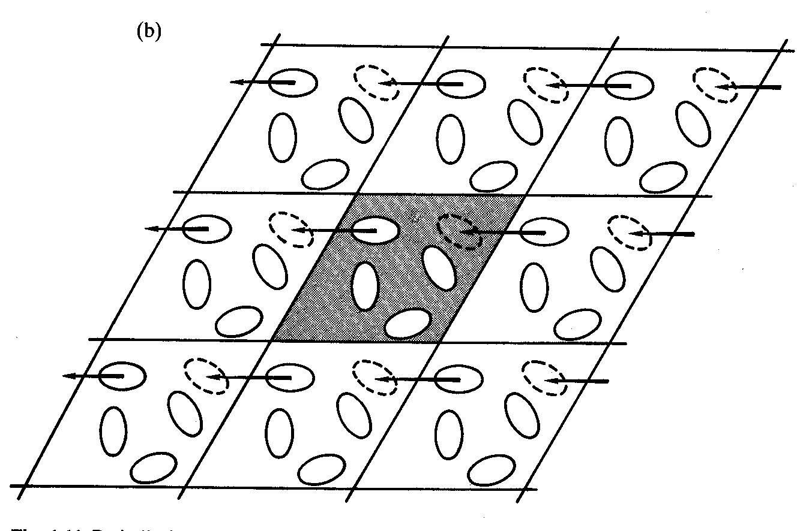
Figure VI.4.1. Periodic boundary conditions in MD simulations imply that the simulation box (central, shaded) is surrounded by identical boxes, each containing images of the molecules present in the simulation box. Periodic boundary conditions maintain the density (each molecule leaving the simulation box is assumed to re-enter from the opposite end). The box size should be sufficiently large compared to the simulated system so as to avoid artifacts induced by periodicity.

e. Limitations of MD simulations

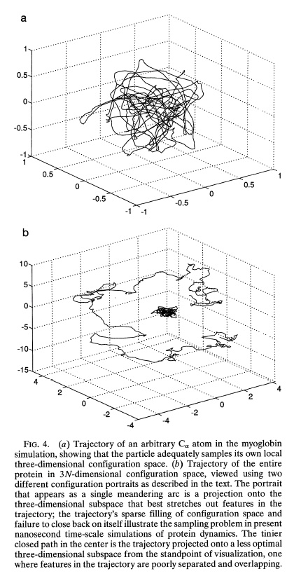
 Full atomic representation → noise → difficulty in discerning the dominant mechanisms of motion → need for methods for filtering out the noise, such as the Essential Dynamics method described below.
Figure VI.4.2

 Empirical force fields → limited by the accuracy of the potentials.

 Time steps constrained by fastest motion (vibrations in bond lengths occur in the femptoseconds (fs) time range and necessitate the use of timesteps of 1-5 fs)

 Inefficient sampling of the complete space of conformations See Figure VI.4.2, from a study of Phillips and coworkers (Clarage et al. (1995) “A sampling problem in Molecular Dynamics Simulation of Macromolecules” Proc Natl Acad Sci USA 92, 3288-92)
10⁻⁹ s
1 s
10⁻³ s
10⁻⁶ s
Reduced Detailed

 Limited to small proteins (100s of residues) and/or short times (subnanoseconds) (see below).

